

**Kazakh-British Technical University**

**School of Information Technologies and Engineering**

Laboratory work №2

**Fundamentals of PowerPoint**

Prepared by: Gainullin D.

Checked by: Abildayeva T.

**Almaty, 2025**

**CONTENT**

Introduction 3

Creating a New Presentation 4

Using Templates 4

Working with Text 6

Inserting Images and Videos 8

Creating Diagrams 9

Hyperlinks and Slide Transitions 11

Animations 12

Sound Accompaniment 13

Protecting the Presentation 14

Conclusion 16

# **INTRODUCTION**

In this laboratory work, we explored the main functions of Microsoft PowerPoint for creating a professional presentation on the topic Innovations in Technology. The tasks included designing a title slide, applying built-in templates, and formatting text with bullet and numbered lists. We also worked with multimedia elements such as inserting images, videos, and background audio, as well as creating charts and adding hyperlinks. Furthermore, we practiced using transitions, animations, and security options to improve the presentation’s quality and protect the final project.

**Laboratory Work: Fundamentals of PowerPoint**

# **Task 1: Creating a New Presentation**

For the task 1 of creating the title slide, we will open a new blank presentation and we will apply a professional theme. We will then type the title Innovations in Technology and we will add the author’s name to introduce the presentation.



Figure 1 – Theme for presentation

In this Figure 1, we opened the Design tab and selected a theme to give the slides a professional appearance.



Figure 2 – Subtitle box

Then we typed the presentation title Innovations in Technology in the title box and the author’s name in the subtitle box. This was done to introduce the topic clearly and set the tone of the work.

# **Task 2: Using Templates**

For the task 2 of using built-in templates, we will insert three new slides with different layouts such as Title and Content, Two Content, and Comparison. We will write short text on each slide about different innovations in technology.

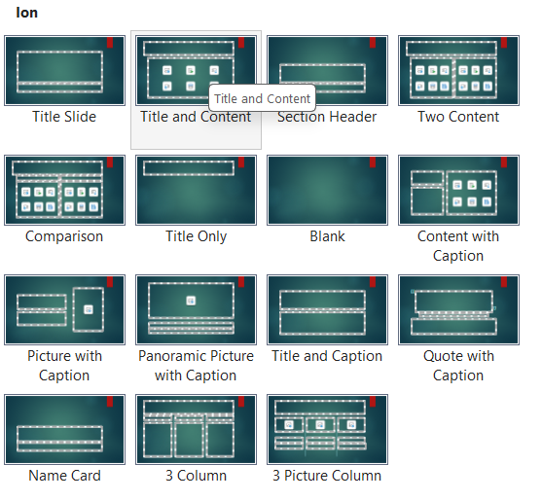

Figure 3 – All designs

As presented in Figure 3, we clicked Home → New Slide and chose different layouts such as Title and Content, Two Content, and Comparison.

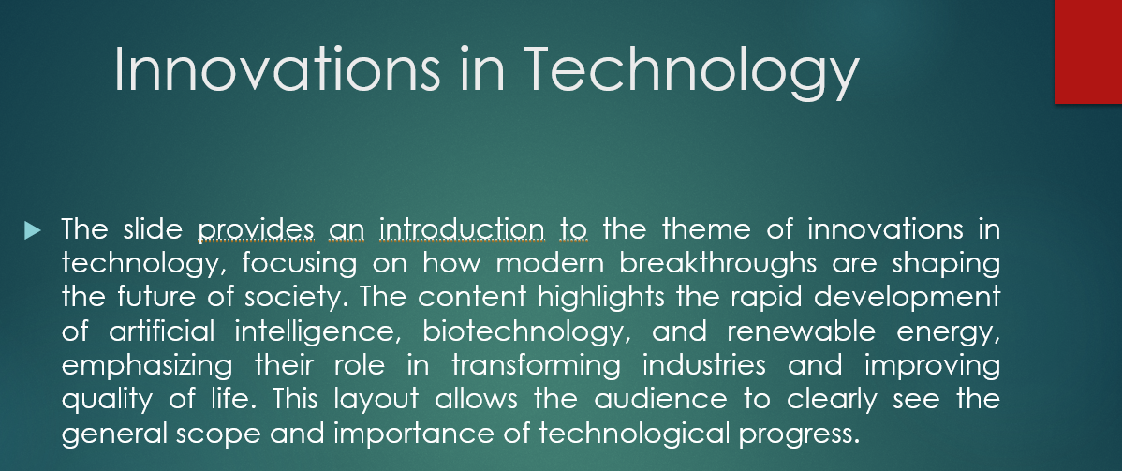

Figure 4 – Description

In this Figure 4, we added text to each slide, briefly describing one innovation in technology.

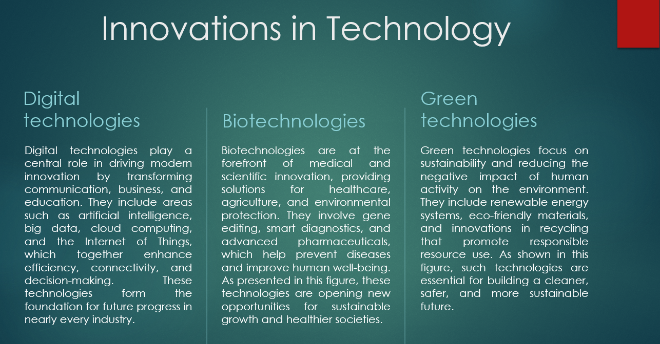

Figure 5 – 3 column title

As shown in Figure 5, this is the second slide (3 columns), I have selected 3 topics on “Technological Innovation”, 1st topic: Digital technologies, 2nd topic: Biotechnology, 3rd topic: Green technologies.



Figure 6 – Advantages and Disadvantages

In this Figure 6, this is a “Comparison title”, in this title I talked about disadvantages and advantages of “Innovations in Technology”. This was done to make the content structured and visually diverse.

# **Task 3: Working with Text**

For the task 3 of working with text, we will create bulleted lists and we will create numbered lists to organize the information. We will also change the font style,

size, and emphasis to make the text clearer and more attractive.

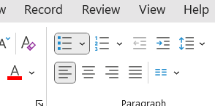

Figure 7 – Bullet style

As shown in Figure 7, we highlighted text and clicked Home → Paragraph → Bullets to create a bulleted list.

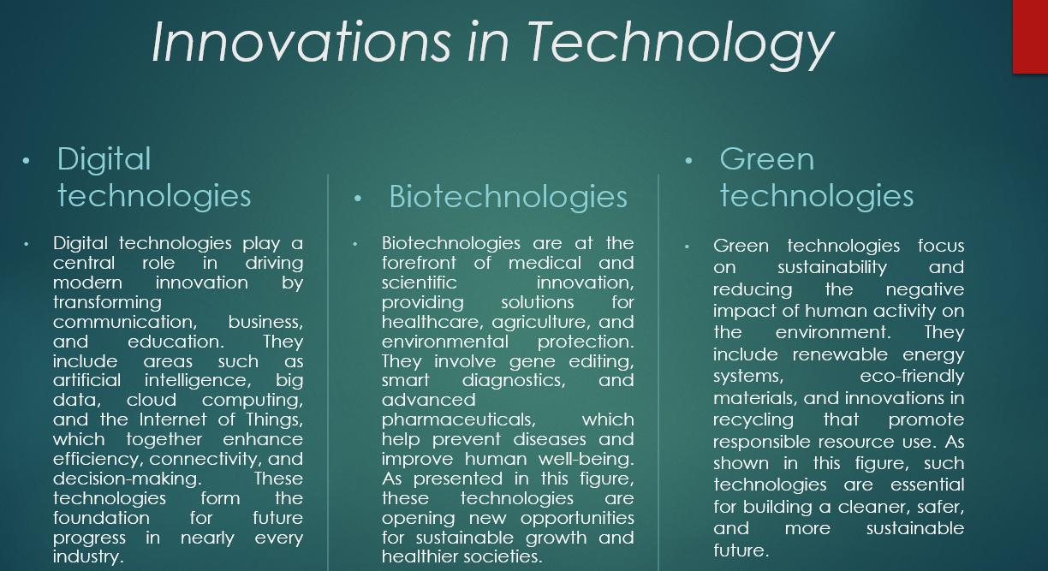

Figure 8 – Bullet and Italic style for presention

As presented in Figure 8, I’ve selected 3rd slide (3 column) and applied bullets style and for title I applied italic style.

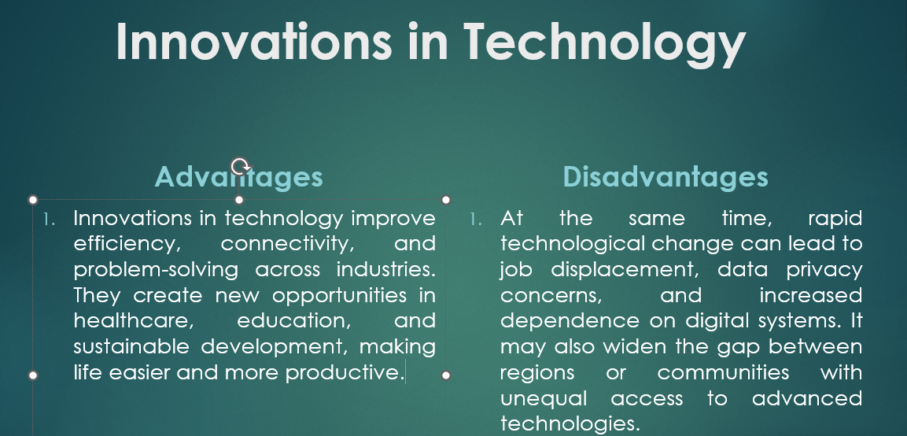

Figure 9 – Numbering and Bold style for presention

As shown in Figure 9, I have selected 4th slide (Comparison) and applied numbering style and for title I applied bold style.

**Task 4: Inserting Images and Videos**

For the task of inserting multimedia, we will add images and we will add a video related to technological innovations. We will resize and crop the images, and we will set the video playback to start automatically or on click.

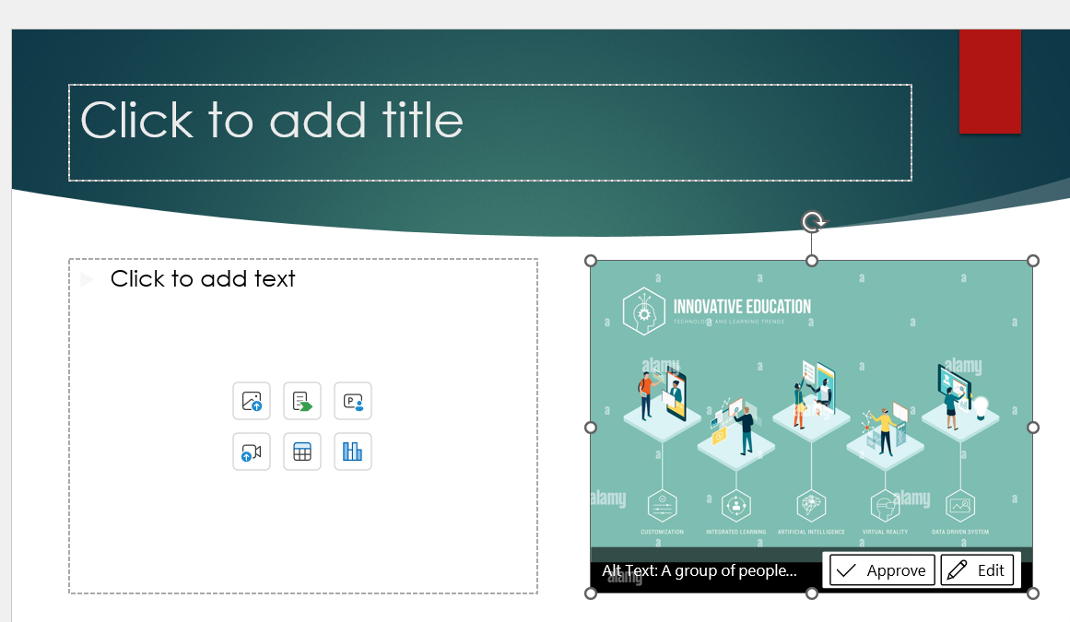

Figure 10 – Downloading a picture

As shown in Figure 10, we inserted an image by clicking Insert → Pictures → This Device, and then adjusted its size with corner handles.

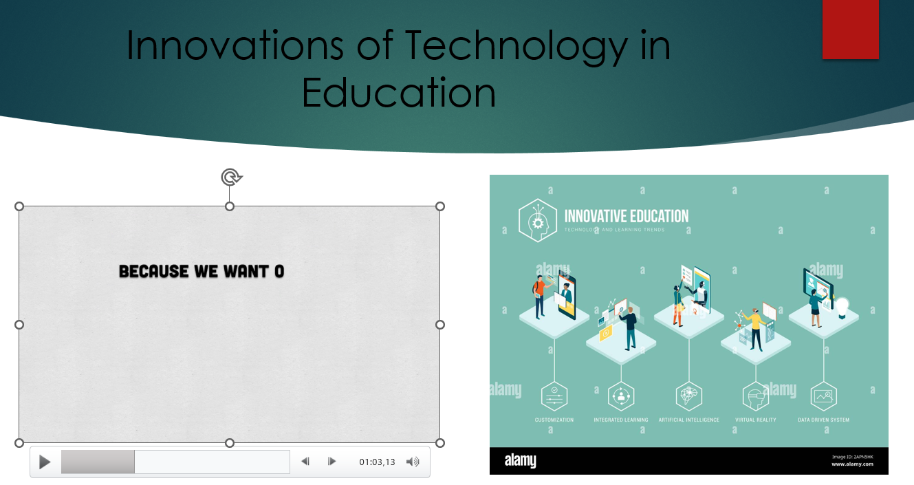

Figure 11 - Downloading a video

As presented in Figure 11, we also inserted a video using Insert → Video → This Device. Playback options were set in the Playback tab to make the video start automatically or on click. This was done to make the presentation visually rich and interactive.

**Task 5: Creating Diagrams**

For the task 5 of creating a chart, we will insert a diagram that will show the growth of internet usage or the AI market. We will edit the data in Excel and we will format the chart to highlight the trends.

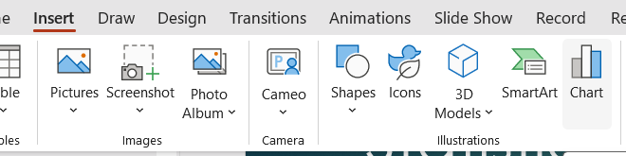

Figure 12 - Chart

As shown in Figure 12, we clicked Insert → Chart and selected a column chart.

Table 1 - Growth of Internet Users

|  |  |
| --- | --- |
| Year | Number of users |
| 2010 | 2.0 B |
| 2015 | 3.2 B |
| 2020 | 4.6 B |
| 2025 | 5.4 B (forecast) |

In Table 1,we have data on a growth of internet users.

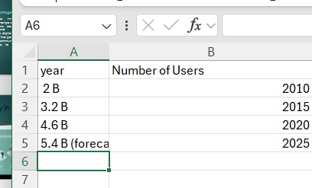

Figure 13 – Data on Excel

In this Figure 13 , we replaced the default numbers in the Excel sheet with real statistics on internet users and the AI market.

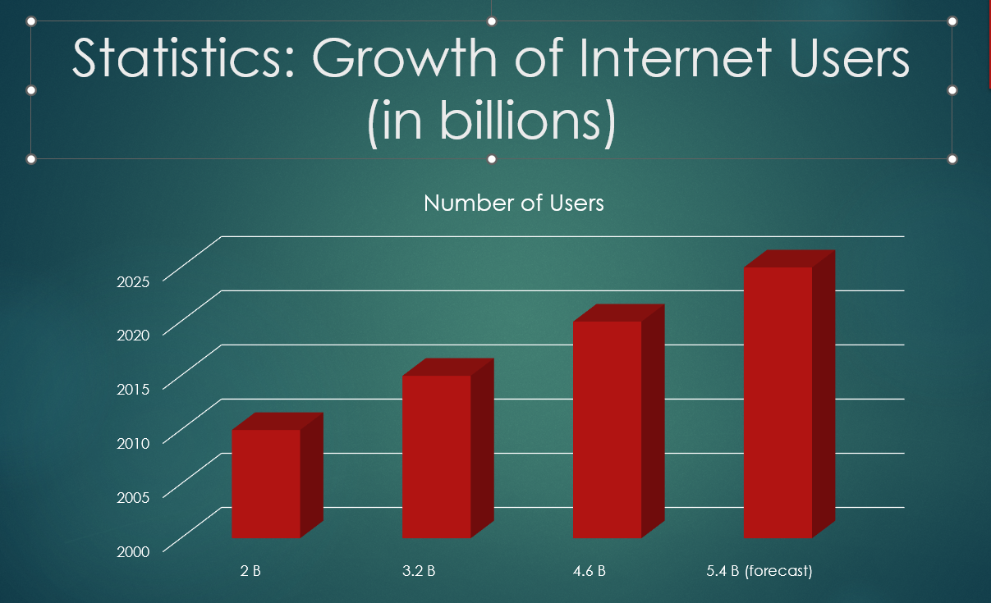

Figure 14 – Diagram of Growth of Internet Users

As presented in Figure 14, our diagram in presentation.

Table 2 - AI market

|  |  |
| --- | --- |
| Year | Market Size |
| 2018 | 10 B |
| 2020 | 22 B |
| 2022 | 52 B |
| 2025 | 190 B |

As shown in Table 2, ,we have data on a Growth of Artificial Intelligence Market.

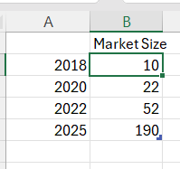

Figure 15 – Excel

In this Figure 15, we have inserted the numbers into an Excel spreadsheet with real statistics on Internet users and the artificial intelligence market.

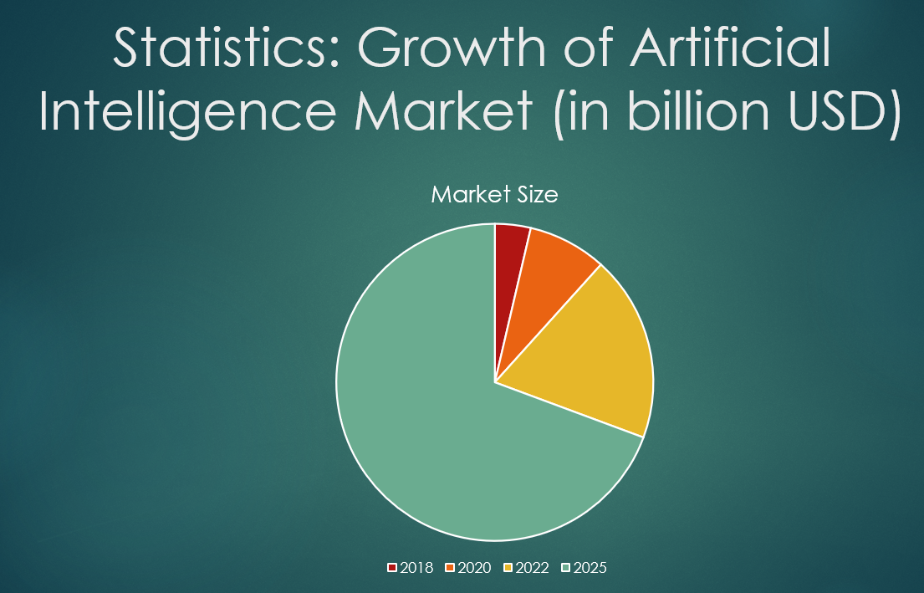

Figure 16 – Pie diagram

As presented in Figure 16, our chart was done. This step was important to visualize data and support the text with clear evidence.

**Task 6: Hyperlinks and Slide Transitions**

For the task 6 of adding interactivity, we will create hyperlinks to external resources and we will apply slide transitions. We will also adjust the transition duration to make the presentation smoother.

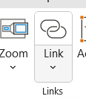

Figure 17 - Hyperlink

As shown in Figure 17, we selected a word and clicked Insert → Link, pasting a web address to create a hyperlink.

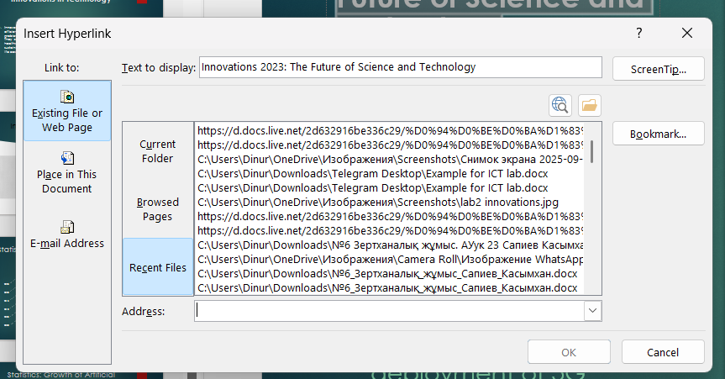

Figure 18 – Address

In this Figure 18, we pinned the link for the message.

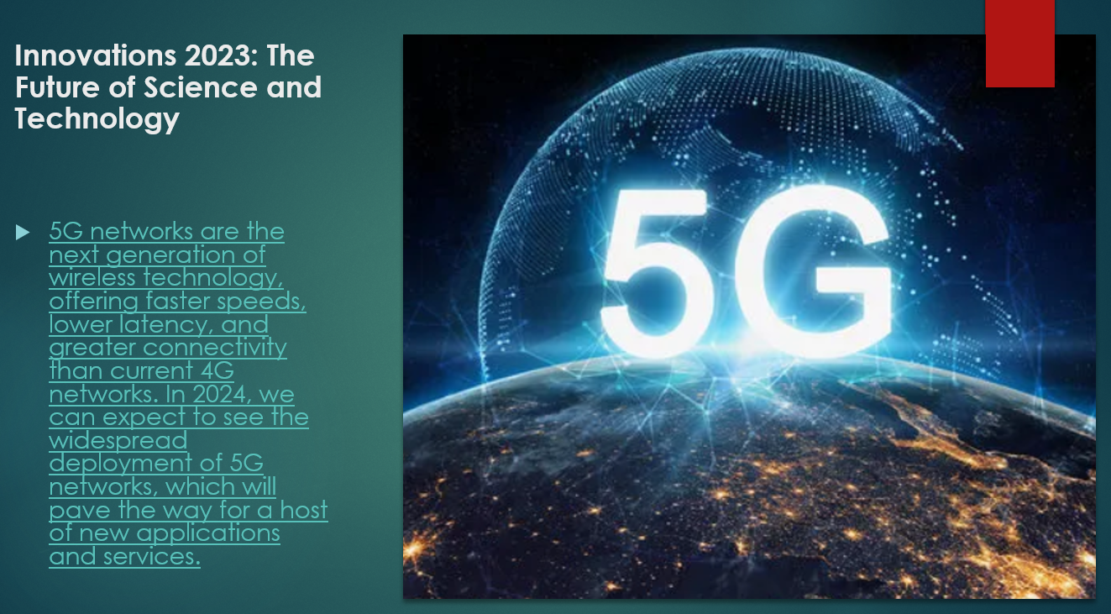

Figure 19 – Slide for hyperlink

As presented in Figure 19, our slide was done for hyperlink.

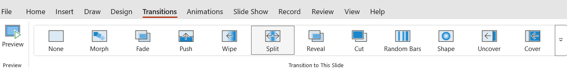

Figure 20 – Transitions

In this Figure 20, we opened the Transitions tab and applied effects such as Fade or Push.These steps were done to make the presentation interactive and smooth.

**Task 7: Animations**

For the task 7 of using animations, we will apply entrance and emphasis effects to both text and images. We will open the Animation Pane, and we will adjust the order, timing, and delay to focus attention on key elements.



Figure 21 – Animations

As shown in Figure 21, we selected text and applied entrance effects in the Animations tab.We clicked Add Animation to assign more than one effect to an object.

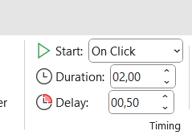

Figure 22 – Duration and delay for animations

As presented in Figure 22, the Animation Pane was opened to control timing, order, and delay. This helped to emphasize key points and keep the audience focused.

**Task 8: Sound Accompaniment**

For the task 8 of integrating audio, we will insert a background music file into the presentation. We will set it to play automatically across all slides, and we will trim the audio if necessary to fit the length of the slideshow.

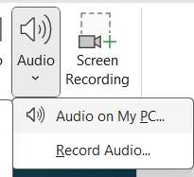

Figure 23 – Audio for presentation

As shown in Figure 23, we inserted background music using Insert → Audio → Audio on My PC.

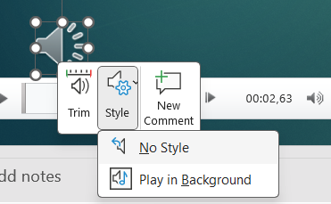

Figure 24 – Background

In this Figure 24, we changed the playback option to Start Automatically and enabled Play in Background.

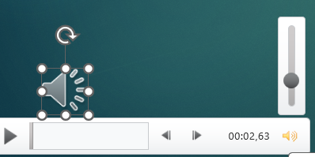

Figure 25 – Volume

As shown in Figure 25, we also reduced the sound using the command so that the sound does not interfere with others and does not distract. This was done to create a pleasant atmosphere without distracting from the content.

**Task 9: Protecting the Presentation**

For the task 9 of protecting and exporting, we will set a password to secure the presentation. Finally, we will export the file as a PDF so that it can be easily shared and opened on any device.

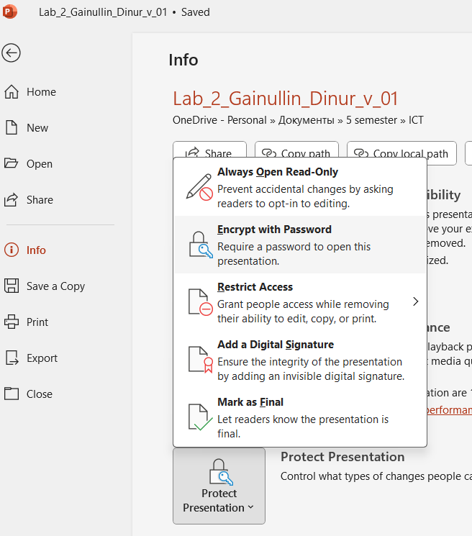

Figure 26 – Password for presentation

As presented in Figure 26, we clicked File → Info → Protect Presentation → Encrypt with Password and entered a password.

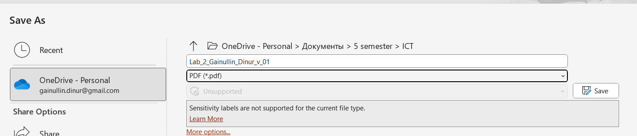

Figure 27 – Export to PDF

In this Figure 27, we selected File → Export → Create PDF to save the final version in PDF format.The exported file was checked to make sure all slides, links, and media worked correctly. These actions were important for security and for convenient sharing of the final presentation.

**CONCLUSION**

In this laboratory work, the skills of creating and formatting a presentation in PowerPoint were successfully applied. All the main tools were tested, including text formatting, multimedia insertion, transitions, and animations. Additionally, audio integration, chart visualization, and document protection were implemented to make the presentation more interactive and secure. Overall, the work provided practical experience in designing effective digital presentations that can be used for academic and professional purposes.